FY22
Passages of the Western Potomac Heritage Area (PWPHA)
Grant Guidelines & Application

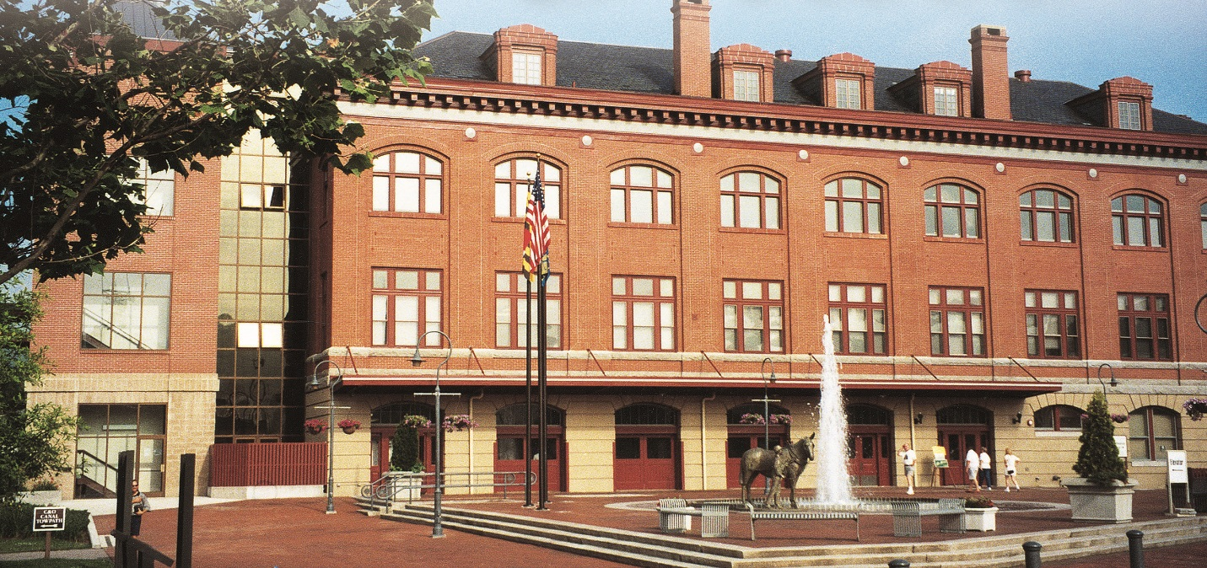

Submission Deadline: October 4, 2021
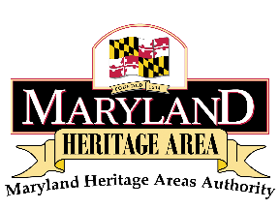
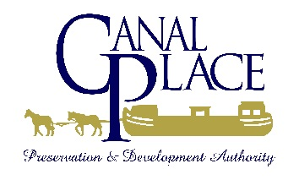

Welcome to the Passages of the Western Potomac Heritage Area Grant Program!

The FY22 Grant Round has been announced and the deadline for applying is October 4, 2021.

Please take a minute to read the enclosed packet thoroughly. It includes the Passages of the Western Potomac Heritage Area FY22:
- Program Overview
- Program Guidelines
- Program Application
- Instructions for Closing Grant
- Final Report
If you should have any questions, please contact Passages of the Western Potomac Heritage Area (PWPHA) Executive Director, Deidra Ritchie, at:
301-724-3655 ext. 101.

Thanks, and good luck,
Deidra Ritchie
Executive Director
Passages of the Western Potomac Heritage Area

Passages of the Western Potomac Heritage Area
Grant Program Overview
INTRODUCTION

Maryland’s Heritage Areas are places to experience – to see, hear and even taste – the authentic heritage of Maryland in ways that you cannot experience anywhere else.

What is the Passages of the Western Potomac Heritage Area?

In 1993, the Canal Place Preservation and Development Authority (CPPDA) was established as an independent state agency of Maryland to create and develop the historical C&O Canal preservation district in the city of Cumberland. Initially, the focus of the CPPDA was on the acquisition and rehabilitation of properties associated with the Canal Place Preservation District. This highly significant place centers on transportation history. The historical, cultural, natural and visitor resources that CPPDA stewards include:
- Western Maryland Railway Station
- Pedestrian footbridge between the station and Riverside Park
- Trestle Walk connection between the station and Chesapeake and Ohio (C & O) Canal towpath
- Shops at Canal Place and associated parking
- Crescent Lawn Festival Grounds
- Footer’s Dye Works building
In 1996, Canal Place became the first certified Heritage Area in the state of Maryland. The Canal Place Heritage Area (CPHA) is governed by the CPPDA which includes representatives from the C&O Canal National Historical Park, Maryland Historical Trust, the City of Cumberland, six members appointed by the governor, and an appointed Executive Director. The Executive Director manages the day-to-day operations of the 11-acre Canal Place Heritage Park and administers the heritage area program. The theme of transportation was selected for the heritage area due to its significance in history. Cumberland was known as a transportation hub due to the development of the Historic National Road, the B&O Railroad, and the C&O Canal.
To date the heritage area encompasses over 1,000 acres of property in Cumberland and Frostburg. In addition, in 2019, the heritage area was re-branded and is now known as the Passages of the Western Potomac Heritage Area (PWPHA). This re-brand reflects the expansion of the heritage area into various portions of Allegany County and covers not on the transportation aspect of our heritage but also our stories along the way.

The PWPHA Heritage Area responsibilities include:
• Preserving or assisting in the preservation of buildings, structures, and settings of historical value;
• Conducting activities to educate the public about the history and significance of the Heritage Area;
• Providing recreational uses of the Heritage Area;
• Facilitating economic development in the Heritage Area, such as through public and private investment in adaptive reuse, interpretive attractions, or other activities.

Mission

Canal Place and the PWPHA’s mission, in cooperation with local, state, and federal stakeholders, is to effectively manage the property and facilities at Canal Place and be a catalyst for the enhancement, preservation, and promotion of the assets and attractions within the Heritage Area in order to foster economic development and heritage tourism in Allegany County.

FY 22 Grant Program Guidelines

Passages of the Western Potomac Heritage Area Mini Grants Program

The PWPHA Grant Program is a source of funding designed to assist and encourage the preservation of historical, archaeological, natural, and cultural resources and support economic development through heritage tourism within the boundaries of the PWP Heritage Area. The Canal Place Preservation and Development Authority (CPPDA) is the management entity for the PWP Heritage Area and therefore approves projects and administers the Grants Program. These Grants are for non-capital or programming activities only and may not be used for administrative expenses or any “bricks or mortar” projects.

Guidelines

The following is general information about the PWPHA Grant Program and instructions for completing the Grant application. PWPHA Grants funding amounts will be from $500 to $5,000 with a “One to One” cash match.

Eligibility Information

- Applicant is a local jurisdiction or non-profit
- Proposed project is consistent with the interpretive theme of transportation as described in the Canal Place Heritage Area Management Plan. Please contact the office for a copy of the management plan.
- Utilizes collaborative partnerships
- Enhances heritage tourism visitation
- Applicant can provide one to one cash match
- Demonstrate ability of applicant to initiate, administer and complete project within proposed timeframe, including the submission of the final report
- Applicant, or project location, is within the boundaries of the PWPHA (please ask if unsure if you are within the boundary)
- Project must not begin before the grant award is announced
- Applicant organization is in good standing with the state of Maryland
- PWPHA and the Maryland Heritage Areas Authority must be acknowledged and logos (provided by Canal Place) must appear on any materials produced or in any publicity for the funded project/program/exhibit. Failure to acknowledge as indicated may result in forfeiture of up to 100% of mini-grant award. Drafts of any printed material must be submitted to PWPHA for approval before completion.
- Canal Place/PWPHA reserves rights to use images and other materials connected with funded grant project/program/product, including use of printed materials in downloadable form on CP/PWPHA’s website(s) and/or social media.

Application Procedure:
Applicants should contact the heritage area Executive Director, Deidra Ritchie, to discuss potential mini grant projects before they begin the application. Applications are due (submitted via e-mail) no later than
October 4, 2021. Late applications will not be accepted.

Evaluation and award selection are based on the completed application and eligible heritage area criteria. Please note: No grant funds may be expended before the date of grant award notification. All projects are to be completed by October 3, 2022 and all funds relating to the project are to be expended by the project completion date. If the Project is completed for an amount less than that reflected in the Project Budget, the amount of the Grant may be reduced and Grantee shall return all unexpended Grant funds to PWPHA. Final grant reporting requirements are to be submitted no later than October 31, 2022. Time extensions for grants may be requested in writing to the Executive Director.

Awarded grant funds will be disbursed 50% after the receipt of an invoice from grant awardees, with the remaining 50% to be disbursed after project completion and receipt of all required grant reporting and an invoice billing for the remaining grant funds. Please note: as part of grantee’s final report, grantee must provide financial documentation to PWPHA of all expenditures of PWPHA grant funds and all cash contributions utilized to meet these requirements. Grantee’s contributions may include funds derived from other non-State public or private sources; provided however, that no State funds are used for any part of the Grantee’s Contribution.

The following types of activities are eligible to receive Mini Grant funding:

Planning | Interpretation
•Feasibility and Planning Studies  •Design Documents  •Research  •Data Recovery  •Other planning activities that support the Certified Heritage Area | •Interpretive Exhibits  •Interpretive Signage  •Wayfinding Signage – Pedestrian only  •Interpretive Brochures  •Educational Programs and Materials  •Other interpretive activities that support  the Certified Heritage Area
Programming (Preference is given to new, or pilot, programs rather than ongoing activities)
•Seminars | •Reenactments
•Conferences | •Commemorations
•Performances | •Festivals

Passages of the Western Potomac Heritage Area FY 22 Grants Program Application

Applicant Information
Date of Application:
Name of Organization:
Address:
Phone #:
Contact Person:
Contact Email:
Is your organization a NON-PROFIT organization? ________________ (If yes, please provide a copy of the appropriate notification letter as an attachment and Federal ID #)) OR a governmental entity? _____________________
Title of Project: ________________________________________________________________________

Amount of Grant requested:

Provide an overall summary of the proposed project (Specifically identify activities the grant funds will be used to support. Maximum of 1 paragraph. If your project is an event, is it a first-time event? A new component of a current event?)

How will this project foster Heritage Tourism? Does this project enhance the heritage area’s transportation theme, or any of the sub-themes? Please explain, be specific. The subtheme should align with the 2014 CPHA Draft Management Plan listed on page one of the executive summaries. To see and understand the subthemes please contact the Executive Director.

Will this project build collaborative heritage partnerships? List partnering organizations and their roles.

Describe how the impact or success of this proposal will be measured. Attendance? Survey? Distribution of materials? Website analytics? Explain.

How will you market the event? Please provide a brief description.

What is the schedule of work for this project? Include a detailed timeline of activities with estimated start and completion dates.
ACTIVITY | START/ COMPLETION DATE
Add rows/columns to table as necessary.

YOUR PROJECT BUDGET OVERVIEW
Funding Your Grant
PROJECT BUDGET EXAMPLE
Work Item (Description) | Mini-Grant Funds Requested (Max. $5,000) | Applicant Proposed Cash Match (The total in this column must match the total amount requested) | Additional Grantee project funding ($) if applicable | Total Project Cost ($)
Brochure Design | $500
Brochure Printing | $500 | $1000
Interpretive Panel | $1000 | $1000
Totals | $2000 | $2000 |  | $4000

Please fill in the budget for your project below. Add lines as necessary.
PROJECT BUDGET
Work Item (Description) | Mini-Grant Funds Requested (Max. $5,000) | Applicant Proposed Cash Match (The total in this column must match the total amount requested) | Additional Grantee project funding ($) if applicable | Total Project Cost ($)
Totals

Additional Information to Include in Your Packet:
- Articles of Incorporation, By Laws
- Certificate of good standing from the State Department of Assessments and Taxation. (You don’t have to pay for the certificate, a printout from the webpage confirming your organizations good standing is sufficient.)
- Letters of support (are encouraged but not required).
- Completed W-9 Form

Application Checklist | Initials
Project located in boundaries of PWP Heritage Area
Accurate Contact information for person(s) in charge of project
Proof of Applicant Non-Profit Status
State Status (In Good Standing)
Government Entity
Detailed Schedule of Work
Included Cash Match Documentation (one to one match)
Included Quotes/ Price Estimates
Completed Project Budget
Mission Statement
Articles of Incorporation, By Laws
Understands acknowledgement of MHAA &
PWPHA is Required
Completed W-9 Form
Understands there is a one to one cash match
Has read/signed the Appendix

Applicant Signature:
Print Name: | Title:
Signature: | Date:

PLEASE NOTE: It is an absolute requirement that the PWPHA and the Maryland Heritage Areas Authority be acknowledged for contribution to this project.

Grant Application Appendix
Disbursement of Grant Proceeds
Mini Grant awards will be announced by November 1, 2021. None of the required match or grant funds may be expended before the date of grant award notification. All projects are to be completed by October 3, 2022, and all funds relating to the project are to be expended by the project completion date. If the Project is completed for an amount less than that reflected in the Project Budget, the amount of the Grant may be reduced and Grantee shall return all unexpended Grant funds to PWPHA. All grant reporting requirements are to be submitted no later than
October 31, 2022.

Awarded grant funds will be disbursed 50% after the receipt of an invoice from grant awardees, with the remaining 50% to be disbursed after project completion and receipt of all required grant reporting and an invoice billing for the remaining grant funds. Please note: as part of grantee’s final report, grantee must provide financial documentation to PWPHA of all expenditures of PWPHA grant funds and all cash contributions utilized to meet these requirements. Grantee’s contributions may include funds derived from other non-State public or private sources; provided however, that no State funds may be used for any part of the Grantee’s Contribution.
Default and Remedies
A default under this agreement shall occur if:
Grantee fails to comply with any of the covenants, agreements, or certifications made by the Grantee in this Agreement;
At any time, any representation or warranty made by Grantee in connection with the Grant, the Agreement, or the Grant Application, shall be incorrect in any manner;
Grantee knowingly makes, or causes to be made, any material misstatement of fact, including an understatement or overstatement of financial condition, in a statement or report required under the Agreement or the Grant Application, for a Request for Disbursement, or affecting the Grant in general;
The Grant funds are not spent in accordance with the terms of this Agreement;
Grantee is in default under any other agreement related to the Project;
At any time during the period of the Grant, there is pending or ongoing litigation with respect to Grantee’s performance of any duties or obligations in connection with the Project, or the Grant, which may jeopardize, or adversely affect, this Agreement or the Project;
Grantee is not performing or completing the Project in accordance with the terms of this Agreement, or in a manner satisfactory to PWPHA;
Grantee has not expended the Grant funds necessary to complete the Project by the Project Completion Date, or Grantee has not provided the Grantee’s Contribution to PWPHA’s satisfaction.
Records and Reports
Grantee shall maintain accurate books, accounts and records in a form acceptable to PWPHA of all transaction’s relation to the receipt and expenditure of the Grant for the Project. All of the books, accounts and records shall be open to the inspection of PWPHA representatives. Grantee shall make its administrative offices available to PWPHA upon request. Grantee Acknowledgement of appendix: Initial and Date____________________

PASSAGES OF THE WESTERN POTOMAC HERITAGE AREA
INSTRUCTIONS FOR CLOSING MINI GRANT

1. Once all grant activities have concluded, review the terms of the grant agreement to ensure that all activities and requirements have been met. Questions or concerns? Please call the PWPHA office.
2. If scope of work, timetable, or budget have changed, please contact the heritage area office before completing this final report.
3. Fill out this Final Report Form, including the budget, and submit it with any invoices, receipts, contracts and other agreements associated with the project. We also request that you attach copies of any printed materials relating to the project, i.e. a brochure, invitation, flyer, etc.
4. Create an invoice for remittal of the remaining Grants funds, indicating to what organization name the check should be made out, and the address to which the check should be sent. Send all these materials together to: deidra.ritchie@maryland.gov and cc: nicole.gray@maryland.gov .
THANK YOU!

FINAL REPORT for FY2022 Grant
Type or print all information. Answer the questions fully. Additional sheets may be used.

GENERAL INFORMATION:
Project Name:
Contact Name:
Address:
Telephone: Cell:
Email:
Date of Report:

1. Narrative Summary of the project. (Include specifics about the activities funded by the Mini Grant.)

2. Describe and quantify the collateral materials resulting from the project (i.e.: publications, website, and signage).

3. Provide the measurable data collected for the Mini Grant project including:
- How many visitors/participants? - compare to previous years if applicable.

- How was the project marketed?

- How was the information distributed?

- Survey results if applicable
4. Specifically describe the acknowledgement of the Passages of the Western Potomac Heritage Area and the Maryland Heritage Areas Authority and provide photo or print documentation of how the acknowledgement is displayed.

FINAL PROJECT BUDGET
Complete the budget table below showing how the funds were spent and matched by the grantee. Attach receipts/invoices including proof of payment (cleared check/credit card or bank statements) for purchased items and documentation of cash match.

Final Report Checklist | Initials
Included Completed Project Schedule
Included Cash Match Proof of Payment (Invoices, Receipts, Bank Statements, Credit Card Statements)
Completed Project Budget & Actuals
Included printed materials showing PWPHA and MHAA Logos
Invoice for Mini Grant balance owed

Certification:

As the President, Board Chair, Treasurer, or Executive Director of the undersigned organization, I am authorized to execute this final report on its behalf. I certify that all information contained in this report is true and accurate.

SIGNATURE: ____________________________________________________________ DATE: _________
PRINTED NAME & TITLE: ____________

