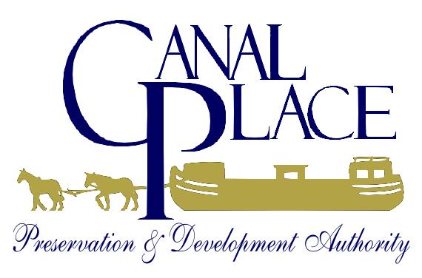

Wes Moore
Governor

Aruna Miller
Lt. Governor

Authority Members

Janice Keene
Evergreen Heritage Center,
Chair

Jeremy Bender
ServiceMaster of Allegany County

Tina Cappetta
U.S. Department of the Interior, NPS

Stuart Czapski
Allegany County Chamber of Commerce

Al Feldstein
Maryland
Historical Trust

Michael Mudge
Allegany County Public Schools

Bradford Nixon
Frostburg State University

Ray Morriss
Mayor, City of Cumberland

Rebecca Ruppert
Allegany College
of Maryland,
Vice-Chair

Deidra Ritchie
Executive Director
Western Maryland Railway Station, 13 Canal Street, Room 301, Cumberland, MD 21502
Phone/Fax: 301-724-3655  Toll Free 800-989-9394  TTY/TDD: 800-735-2258
E-mail: mail@canalplace.org  Web Site: www.canalplace.org

May 3, 2024

River Park at Canal Place Project Manager RFP

Applicants: I have received several additional questions regarding the RFP advertisement for the River Park at Canal Place Project Manager that is due into the CPPDA May 15, 2024.

1. Will the project deadline of May 15, 202 be extended. No, it will not be extended. We would like to hire this position ASAP. So, the deadline to apply is still May 15, 2024.

2. How long will the project manager position last? It will last as long as it takes to complete the River Park project. We are hoping to have the project completed no later than 2030. Those terms will be spelled out in the awardees contract.

3. Can the project manager/firm bid on components of the project? No, grant funding does not allow this.

Thank you, Deidra Ritchie

